**Exp 6** OBSTACLE DETECTOR

**CIRCUIT DIAGRAM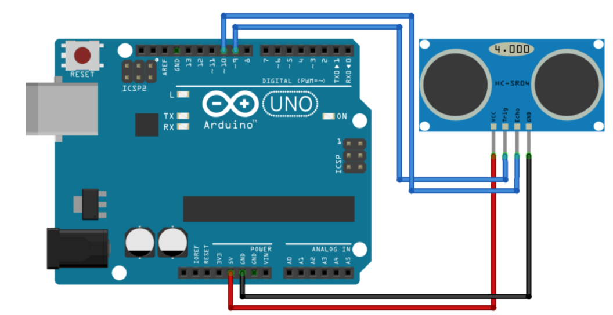THEORY**

**CONCEPT USED**

An Ultrasonic Sensor is a device that measures distance to an object using Sound Waves. It works by sending out a sound wave at ultrasonic frequency and waits for it to bounce back from the object. Then, the time delay between transmission of sound and receiving of the sound is used to calculate the distance.

T / 2

By divide the distance formula by 2 because the sound waves travel a round trip i.e from the sensor and back to the sensor which doubles the actual distance.

**LEARNING AND OBSERVATION**

Ultrasonic device is a distance measuring and detector device. It can be used where distance of a point to a specific point has to be measured. As an detector it can be used where detection of anything, counting and safety are concerned.

**PROBLEM AND TROUBLESHOOTING**

While making the circuit, connection are needed to be maintained corrected. Problem which I faced while performing is that , the reading shown by sensor are fast which are then corrected by giving a specific delay.

**PRECAUTIONS**

1. Connections must be tight and correct.
2. Coding must be right.
3. Components used must be working properly.
4. Before uploading the program , Arduino must be connected.

**LEARNING OUTCOMES**

Ultrasonic is an a device which emits an ultrasound at 40 000 Hz which travels through the air and if there is an object or obstacle on its path It will bounce back to the module. Considering the travel time and the speed of the sound distance can be calculated.By this reason it can be used in:

1. Measuring a tank level
2. Distance measurement
3. Production line sensors

And many more.